One House, One Family At a Time
Gardi Sugdub, Panama

ONE HOUSE, ONE FAMILY (OHOF)-PANAMA, IS A JOINT PROJECT BETWEEN DISPLACEMENT SOLUTIONS AND THE GUNA INDIGENOUS COMMUNITY OF GARDI SUGDUB IN PANAMA. THE OBJECTIVE IS TO BUILD TRADITIONAL HOUSES FOR SOME OF THE MOST VULNERABLE FAMILIES OF SAID COMMUNITY TO HELP GUARANTEE THEIR SUCCESSFUL PLANNED RELOCATION AS A RESULT OF CLIMATE CHANGE.

DURING THIS FIRST PHASE OF OHOF, WE EXPECT TO BUILD 25 TRADITIONAL HOUSES IN THE STYLE OF THE GUNA PEOPLE (WHICH WILL BENEFIT ABOUT 125 PEOPLE). TOGETHER WITH THE 300 "MODERN" HOUSES CURRENTLY PLANNED, AND THE FIRST 100 CURRENTLY UNDER CONSTRUCTION BY THE GOVERNMENT OF PANAMA, WILL PROVIDE PERMANENT AND LASTING HOUSING SOLUTIONS FOR THE GARDI SUGDUB COMMUNITY WHICH HAS BEEN FORCED TO MOVE DUE TO CLIMATE CHANGE.

Displacement Solutions (www.displacementsolutions.org) has been actively/continuously working in Panama since 2014 with our local partner, the indigenous community of Gardi Sugdub. In 2014 after learning that the community of Gardi Sugdub had decided to relocate from their island to the mainland, Displacement Solutions (DS) started a long-term collaboration with the community, starting with a visit and a mission report entitled, The Peninsula Principles in Action. Climate Change and Displacement in the Autonomous Region of Gunayala, Panama; Mission Report. The report made this case visible at both the national and international levels. Most importantly, it also contributed to summarize the information about what has been done, and proposed a path for the Panamanian and other international stakeholders such as the Inter-American Development Bank, to garner support for the community and move forward with the project.

In fact, as a direct result of Displacement Solutions' reports on this case, the Panamanian government increased its original offer of building only 56 houses, and committed to build the 300 houses needed to relocate the entire community. In addition, the Inter-American Development Bank provided financial support to hire a consulting team to work with the community to prepare a relocation plan. Over the last four years, the construction of the new community has moved slowly but continuously. Despite the support from the Panamanian government to build 300 houses as well as the appreciation expressed by the Guna community, the project lacks a culturally appropriate approach. DS's OHAF project aims to correct one of the main deficiencies of the project, by building traditionally designed Guna houses behind the modern houses.

Traditional housing prototype to be built through this project
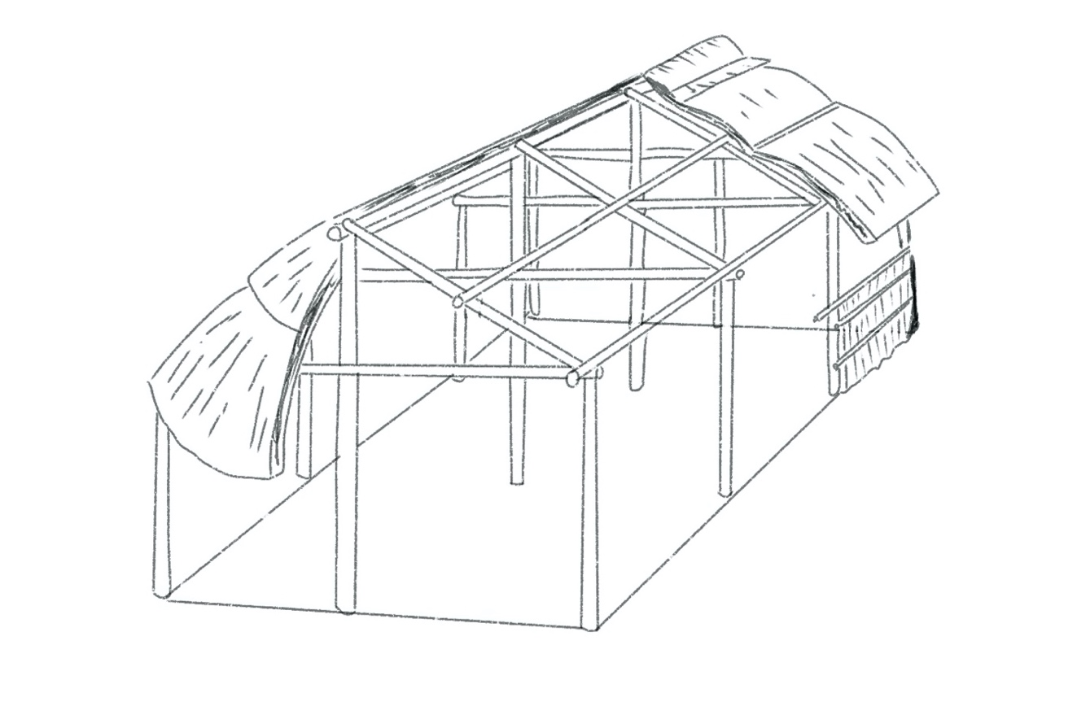
Traditional housing that is sought to be built with funds from this project. This traditional house of 10 x 6 meters will be in the back of each of the new houses built by the government of Panama (Drawing by Gabriel Arenas).

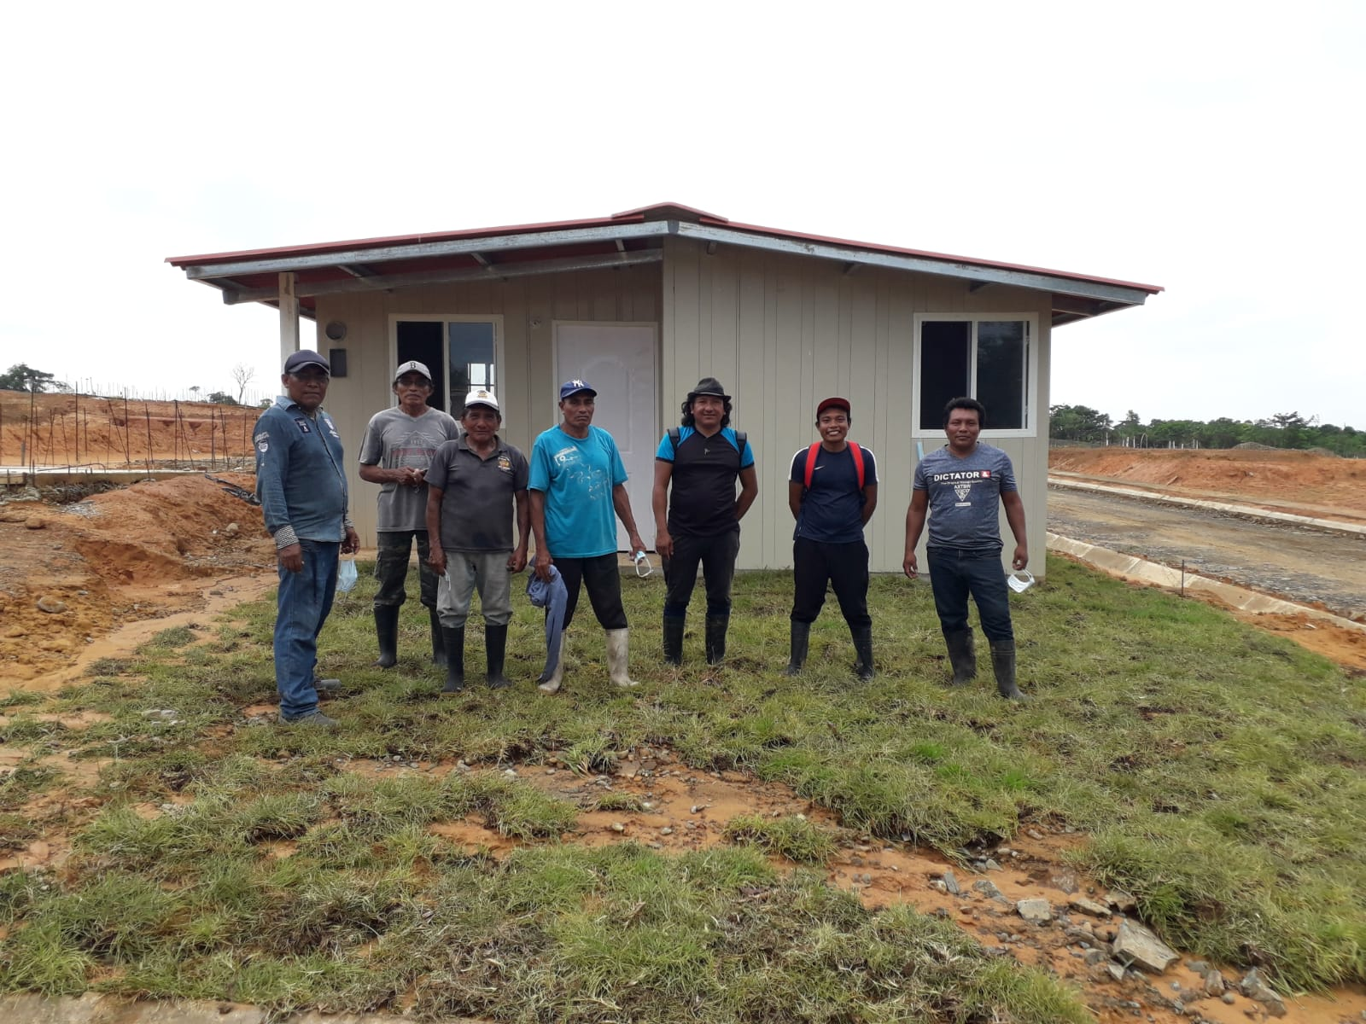
Guna indigenous workers participating in the construction project of the new settlement in Gardi Sugdub.

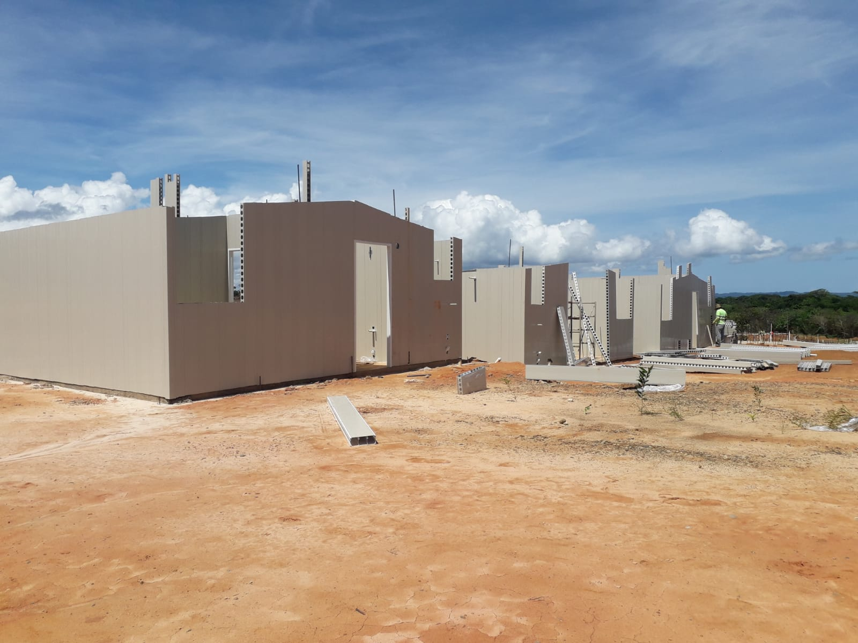
Back of prefabricated houses currently under construction by the Panamanian government. The traditional Guna houses for the OHOF project will be built on the lot behind each house.

WHAT YOU CAN DO

A problematic aspect of the design of the "modern" house that the members of the Gardi Sugdub community will receive is that the structure will not be able to support the weight of the hammocks used for sleeping. Hammocks have a very important cultural and symbolic meaning for the Guna people, as they differentiated them from the more primitive "animal men". During the day, the hammocks are folded and hung out of the way, opening more internal space in the house and allowing other uses of said space. The Gunas describe the hammocks used by the sailas (chiefs) and argars (chief spokesmen) in the Casa del Congreso (Gathering House) as their spirit and compare them to their flag. With the current conditions of resettlement to the mainland, the Gunas of Gardi Sugdub will be forced to sleep in beds, which they are not used to doing.

The Gunas of Gardi Sugdub pragmatically accepted the "modern" housing model offered by the Panamanian government for their resettlement to the mainland, to avoid conflicts and for fear of losing out on the project if they showed any type of opposition. Instead, the Gunas made sure that the lot where the house would stand was large enough to eventually build a traditional house behind it. Thus, the community managed to make each lot three hundred square meters. Each "modern" dwelling is 41 square meters in size, and consists of two bedrooms, a living/dining room, a kitchen, and a bathroom (with sink, toilet, and shower). The laundry area is located at the back of the house.

The prefabricated material of the "modern" houses make them very hot, which will make it very difficult for families to live comfortably and to adapt to their new environment. It is important to remember that the Gunas live in a humid tropical area where average temperatures are 40 degrees Celsius or more. Unfortunately, not all members of the Gardi Sugdub community have the financial resources to build traditional housing to complement and/or replace the "modern" housing.

With this project, Displacement Solutions seeks to make the original dream of the Gardi Sugdub community of being able to have traditional housing alongside "modern" housing come true. Likewise, it seeks to create additional, more open spaces that make life "livable" and facilitate adaptation to the new space and way of life. Cultural discrepancy and the use of inappropriate materials have caused the failure of many resettlement projects in many parts of the world. The Gardi Sugdub community, as well as Displacement Solutions, and all those interested in solving the issue of climate displacement, have an interest in making the Gardi Sugdub relocation as successful as possible.

For all the above and after consulting the community, we have concluded that $2,000 (USD) would cover the materials to build a traditional house, ten meters long by six meters wide. The wood for the construction of the houses would be purchased in Panama City, so it does not deplete the forest in the region, which is a protected area. The reeds for the walls and the thatching used for the roof can be obtained in the region, although the latter is somewhat scarce. The floor will be made of clay, which follows the traditional structure.

The land where the New Gardi Sugdub is being built is owned by the community, and the homes from the Panamanian government will be delivered and assembled free of charge to the families of the community. The construction of the traditional houses for this project will be done by the members of the community themselves, who will help build the houses for each family, following a set process. Low-income people and families that include elderly family members will have priority. The logic used for this decision is that it would be more difficult if not impossible for them to purchase and adapt to sleeping in beds instead of hammocks. In this way, the traditional house construction project also hopes to contribute to strengthening ties between community members.

For $2,000, you can personally help a family rebuild their lives with dignity and support their cultural integrity. Your contribution will cover the acquisition of materials for the construction of a traditional house. Contributions of any amount are accepted. We can assure you that 100% of your contribution will be spent on these costs. All DS contributions to the OHOF project are made free of charge, and all funds raised go directly to the Guna indigenous community of Gardi Sugdub in Panama.

Displacement Solutions will carry out a complete supervision of this project and will guarantee the total responsibility and transparency of the activities carried out with your donations. This will include posting regular updates, reports and photos.

FREQUENT QUESTIONS

1. How much does each house cost?

The total cost associated with each traditional house includes the cost of materials (timber, reeds for the walls, and thatching for the roof), and administrative costs.The total cost of materials to build a traditional house is US$2,000.

2. How many people fit in each traditional house?

It depends. Traditional houses have multiple purposes. At night the hammocks are used to sleep and in the proposed size, between 6 and 8 hammocks will easily fit. During the day, the hammocks are put away so the space can be utilized for many other uses.

3. Where will the houses be built?

The houses are built on land owned by the Gardi Sugdub community, with an elevation of approximately nine meters above sea level, about a kilometer from the coast. They will be added to the prefabricated houses built by the Panamanian government, so they can utilize both spaces.

4. Who owns the houses?

The families of the community of Gardi Sugdub will be the owners of the prefabricated houses built by the government of Panama and of the traditional houses for which Displacement Solutions raises funds, as part of the OHOF project.

5. How are beneficiary families selected?

The community of Gardi Sugdub will implement a rigorous process to select the order of the beneficiary families, having as main criteria the level of income and the elderly who find it more difficult to adapt to living in modern housing without hammocks.

6. Do OHOF families pay rent?

No, the prefabricated houses that the government of Panama builds, and the traditional housing that is proposed are provided free of charge and with transfer of deeds to each of the 300 selected families.

7. Who maintains the houses?

Residents and the community will provide the required maintenance of the houses.

8. How many traditional houses have been built so far?

No traditional houses have been built so far in the relocation site. The goal of the first phase of this project is to build the first 25 traditional homes.

9. Why is OHOF necessary?

OHOF is needed because climate displaced people everywhere, including Panama, need direct help that they do not receive right now. Beyond providing homes for some very disadvantaged families, OHOF aims to point out that climate displaced people have rights like everyone else and need a suitable home to live a fulfilling life.

10. Will there be a Phase 2?

Yes, this is very much the plan since in total there are 300 families that will be relocating, but our priority is to start with Phase 1 and gain momentum to continue to support this project.

11. Will 100% of my contribution be used for OHOF?

Yes, 100% of any contribution you make is sent to the Gardi Sugdub community to build OHOF homes.

12. Does DS make money from the OHOF program?

No, all our efforts at OHOF are provided free of charge and in support of the community.

13. Can I visit OHOF housing sites?

If you are a contributor to this project and speak Spanish, Displacement Solutions will help facilitate direct communication with the Gardi Sugdub community regarding a visit.

14. Can I contact DS directly with more questions?

Yes, feel free to write to us at any time.

Together, we can solve climate displacement!

One Step at a Time: The Relocation Process of the Gardi Sugdub Community in Gunayala, Panama. Mission Report. Displacement Solutions, 2015; An Overview on the Relocation of Guna Communities in Gunayala, Panama. Mission Report. Displacement Solutions, 2016.

